How to Use Miracast in Pico Devices

# Device Projection Screen

The user needs to project VR scenes in the all-in-one machine onto a large screen for others to watch, which needs a projection screen. Pico provides binocular and monocular screen projection methods.

## Goblin Projection Screen

### Binocular Screen Projection Scheme



#### Binocular Screen Projection Method 1

1. Screen projection App available on: <https://pan.baidu.com/s/1o7Lh1Tg>
2. Connect the Goblin device to the laptop, and copy the download software to the root directory of the Goblin device;
3. Go to "File Manager - Installation Package" to install the application "Wireless Projection Screen";
4. Press the “Home” key to return to main menu;
5. Find a TV set or Mi Box with the Mircast function (Mi TV is recommended);
6. Turn on the TV, and find and open "Wireless Display" in "My Applications";
7. Put on the helmet, go to the "My Applications" list, and find and and open "Wireless Projection Screen”;
8. After a moment, the image of the helmet will appear on TV;

#### Binocular Screen Projection Method 2

1. Find a TV set or Mi Box with the Mircast function (Mi TV is recommended);
2. Find and open "Wireless Display" in "My Applications”;
3. Open and put on the all-in-one machine, long press the "Confirm” and “Volume -" key combination at the same time to enter the 2D Settings interface;
4. pull down to find "About Device", and click to enter;
5. Aim at the PUI version number with the cursor, and successively click the “Confirm” key 8-10 times;
6. Return to the previous menu, and click the "Developer Options" button in “About Device” to enter;
7. pull down, click the "Projection" option at the bottom, click the then appearing three dots on the top right to select all the options, and then the device will be automatically connected to the TV.
8. Connection usually takes half a minute, and the image in the helmet will appear on the TV.

### Monocular Screen Projection Scheme

1. Execute the “adb” command to make sure that the computer has the “adb” tool;
2. Connect the “Little Monsters” to the computer, start the “adb” tool, and enter “adb shell setprop persist.pvr.wfd.enable 1”, as shown in the following illustration;

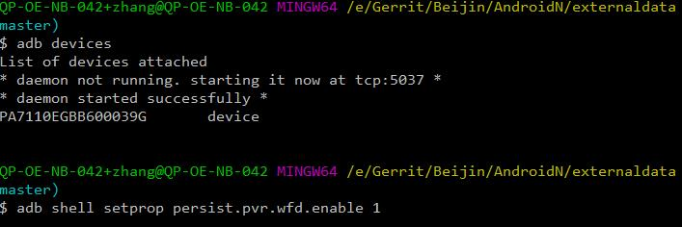

1. Reboot the machine after execution of the above command;

Remarks: The above method is provided for the user to use only as the alternative scheme as it is for internal use in research and development. Blurred screen and other problems are identified in the current self-testing in research and development, and the screen projection effect is not stable enough.

## Pico Neo Projection Screen

1. Find a TV set or Mi Box with the Mircast function (Mi TV is recommended);
2. Find and open "Wireless Display" in "My Applications”;
3. Long press "Confirm” and “Volume-" keys at the same time to enter the 2D Settings interface;
4. Pull down and click "Display" to enter;

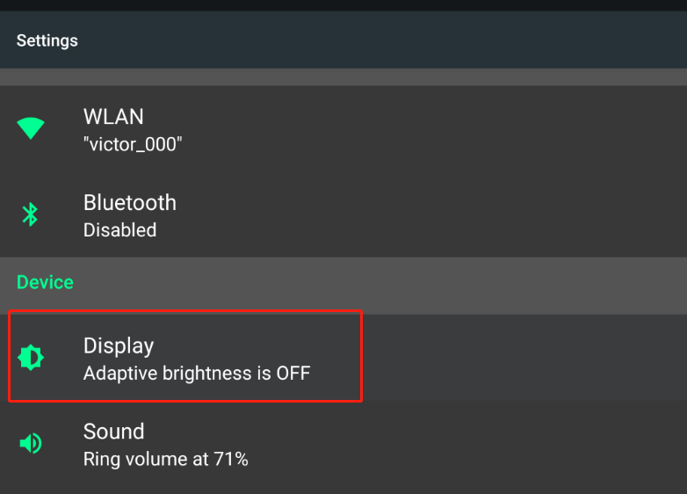

1. Enter the "Display" interface, pull down, click the "Projection" option at the bottom, click the then appearing three dots on the top right to select all the options, and then the device will be automatically connected to the TV.

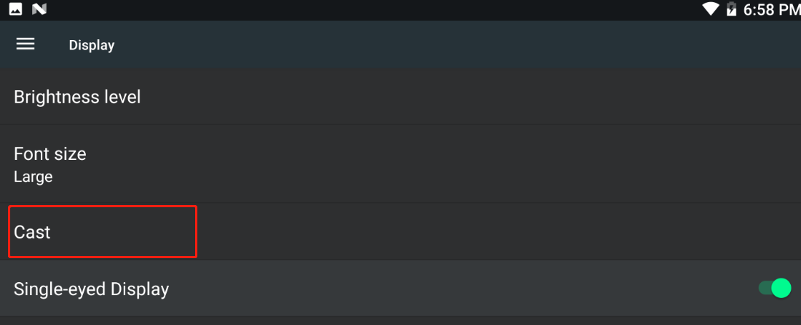

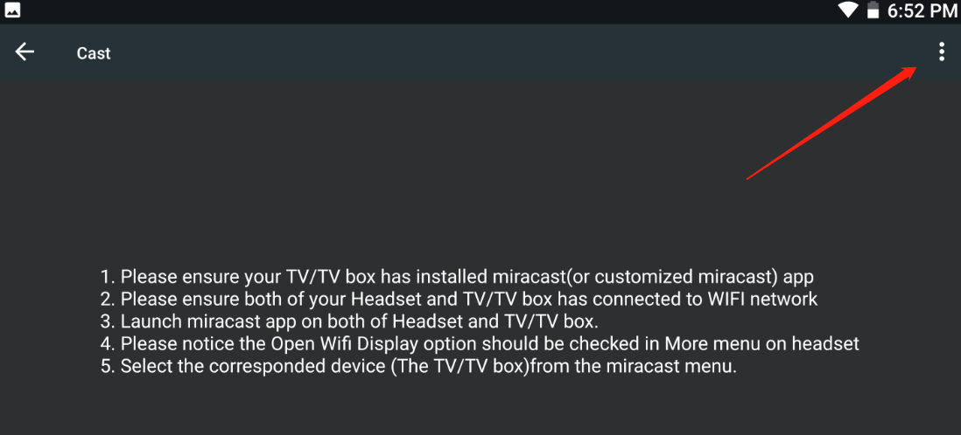

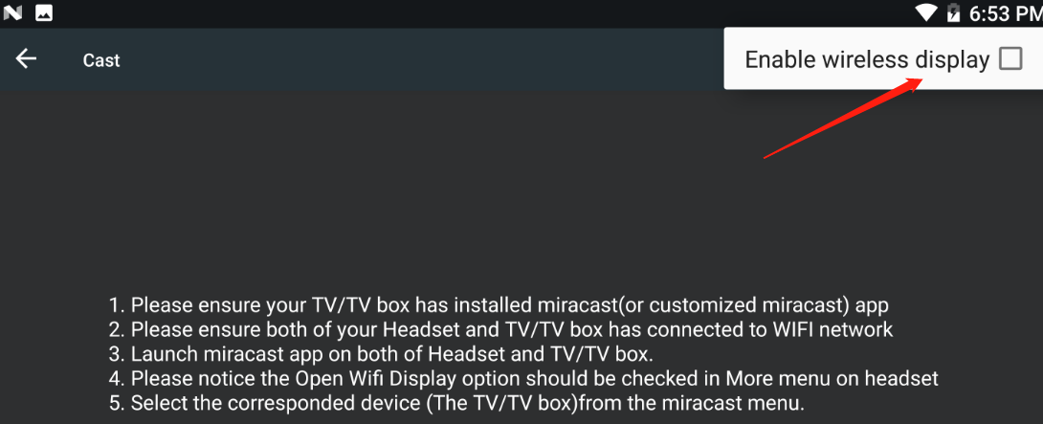

1. Connection usually takes half a minute, and the image in the helmet will appear on the TV.
2. If the user needs to switch to “Monocular Screen Projection”, he/she needs to open “Monocular Screen Projection” in the display interface, as shown in the following illustration;

